**Scripting Task**

**Task Description:**

1. Create a shell script to print the HTTP error code of guvi.in & print, the success/failure message based on the error code response

**shell script to print the HTTP error code of guvi.in & print**

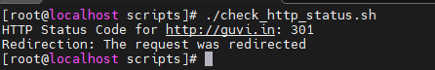  
  
script:

#!/bin/bash

# URL to check

URL="http://guvi.in"

# Get HTTP status code

status_code=$(curl -s -o /dev/null -w "%{http_code}" "$URL")

# Print the status code

echo "HTTP Status Code for $URL: $status_code"

if [[ "$status_code" -ge 200 && "$status_code" -lt 300 ]]; then

echo "Success: The request was successful"

elif [[ "$status_code" -ge 300 && "$status_code" -lt 400 ]]; then

echo "Redirection: The request was redirected"

elif [[ "$status_code" -ge 400 && "$status_code" -lt 500 ]]; then

echo "Client Error: There was an error with the request "

elif [[ "$status_code" -ge 500 ]]; then

echo "Server Error: The server failed to fulfill the request "

else

echo "Unknown status code received"

fi

2.Given a file, replace all occurrence of the word "give" with "learning" from 5th line till the end in only those lines that contain the word "welcome"

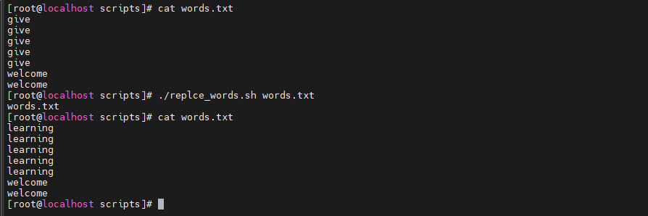  
  
Script:

#!/bin/bash

# Check if filename is provided

if [ $# -ne 1 ]; then

echo "Usage: $0 <filename>"

exit 1

fi

filename=$1

# Check if file exists

if [ ! -f "$filename" ]; then

echo "Error: File '$filename' not found"

exit 1

fi

echo $filename

sed -i '1,$ { s/\bgive\b/learning/g }' $filename